**Ali Isa AbdulHusain Hasan**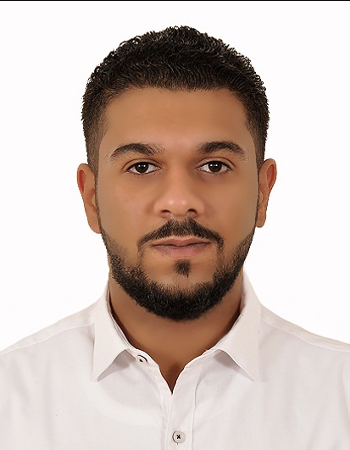

ــــــــــــــــــــــــــــــــــــــــــــــــــــ

**Contact :**

Kingdom of BAHRAIN

Arad house 619

Road 4223 Block 242

**Personal details :**

CPR Number : 940207214

Nationality : BAHRAINI

**Phone** : **36711321**

Gender : Male

Birth Date : 22-2-1994

Place of birth : Muharraq

Marital Status : Single

**EDUCATION:**

Muharraq Commercial Secondary School for Boys

**Commercial 68.8%**

**EXPERIENCE:**

I Work before in midway as shilf boy for 1 year

I work now in JBF ALBAHRAIN as packing for 1 year

**INTERPERSONAL SKILLS :**

Hard working and responsible .

Good communication skills .

**Languages**:

Arabic

English

**Personality Skills :**

Confident and friendly .

Productive and responsible .

Helpful and indulgent .

**References:**

**Available upon reques.**